**SMART STICK FOR BLIND PEOPLE**

**ABSTRACT:**

**This paper describes ultrasonic blind walking stick with the use of ESP32. According to WHO, 30 million peoples are permanently blind and 285 billion peoples with vision impairment. If u notice them, you can very well know about it they can’t walk without the help of other. One has to ask guidance to reach their destination. They have to face more struggles in their life daily life. Using this blind stick, a person can walk more confidently. This stick detects the object in front of the person and give response to the user either by vibrating or through command. So, the person can walk without any fear. This device will be best solution to overcome their difficulties.**

**KEYWORDS: ESP32, Ultrasonic sensor, walking stick.**

**INTRODUCTION:**

**Adaptability and Flexibility for blind person can be define as ability to displace with conviction and welfare to his domain but it is not happened without science and education of technology we introduced one system which is made useful for blind people, with the help of it those people can detect obstacle in front and prevent her/himself. Smart stick for blind man is one of the self-operating robot that follows a line that drawn on the floor. The walking stick is an alternative to the traditional walking stick. Here ESP32, Ultrasonic sensors and Buzzer are used.**

**ESP32 is a series of low-cost, low-power system on a chip microcontroller with integrated Wi-Fi and dual mode Bluetooth. Ultrasonic sensors are used to detect the object in the front of the person by measuring the distance between the object and the stick. A Buzzer or beeper is an audio signalling device, which may be mechanical, electromechanical, or piezoelectric. Here a buzzer vibrates when an obstacle is detected.**

**In order to improve the safety of visually challenged users and enhance their awareness of their surroundings while navigating in outdoor environment, a smart device id needed.**

**The proposed device can detect obstacles as well as terrain changes in the user’s path.**

**BLOCK DIAGRAM:**

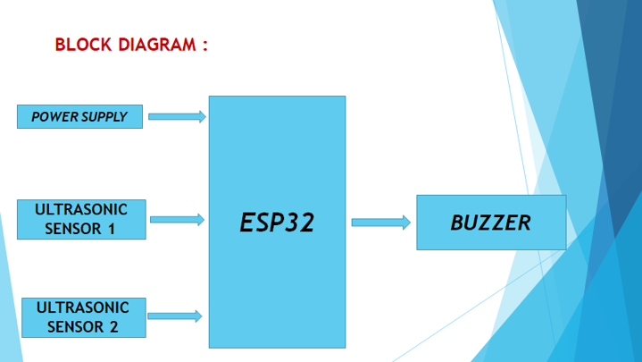

**HARDWARE EQUIPMENTS:**

**1.ESP32:- It** is a series of low-cost, low-power on a chip microcontrollers with integrated Wi-Fi and dual-mode Bluetooth **.**

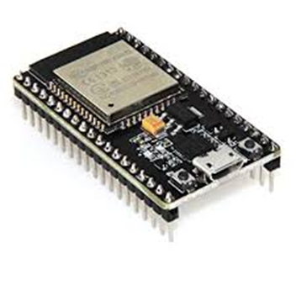

**2.ULTRASONIC SENSOR:** **Ultrasonic sensor is used to detect the object in front of the person. HC-SRC04 ultrasonic sensor has 4 pins-ground, Vcc, trigger and Echo. It ranging from 2cm to 400cm. Mainly it has two opening –one is transmitter which is used to transmit the signal and another one is receiver which is used to receive the signal. It sends ultrasound waves at high frequency and receive back the signal.**

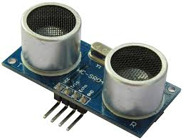

**3.BUZZER: A buzzer or beeper is an audio signalling device. Typical uses of buzzer and beepers include alarm devices, timers, and confirmation of user input such as a mouse click or keystroke.**

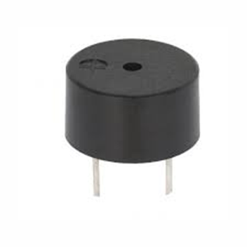

**METHODOLOGY:**

**The working behind this blind stick is that it is used for special purpose as a sensing device for the blind people. It is widely used to detect objects using ultrasonic sensor.**

**If any object is present, the ultrasonic sensor detects the objects by measuring the distance between the object and the user.**

**Here two ultrasonic sensors are used to detects the objects, one of the ultrasonic sensor is used to detect the lower objects and other one sensor is used to detect the upper object and sends data to ESP32 development board.**

**To determine the distance of an object, calculate the distance between sending the signal and receiving back the signal.**

**FUTURE SCOPE: A variety of future scope are available that can be used of with the stick such as usage of Global positioning System can help the blind person to source to destination route information. GPS can help to find the shortest and best path as accordingly to Google (Bing map based on real time coordinates). GSM attachment can help in future for any immediate casualty help. It can also contain special arrangement to connect the walking stick to aadharcard of blinds, helping the government serve the physically disable even better. Water sensor that sense any kind of water allowing the safe walk of the blind people in order to avoid slipping.**

**APPLICATION:**

**Sensors and signal processing based technologies are recently using for the mobility of blind people. To assist the blind people a smart walking stick is designed in such a way that the stick operates just like a radar system that uses ultrasonic sonar sensor to identify the fixed and moving objects.**

**CONCLUSION:**

**The Blind Walking Stick has been finally made into prototype which can be used to guide the blind. Its aims to solve the problems faced by the blind people in their daily life. The system also takes the measure to ensure their safety. This project will operate to help all the blind people in the world to make them easier to walk everywhere they want. It was done to help the blind to move infront very well. It is used to help the people with disabilities that are blind to facilitate the movement and increase safety.**